**BIOINFORMATICS ASSIGNMENT 2** **(Day 6 - 10)**

**-Pradeep Ram**

**NGS DATA QUALITY CHECK (DAY 6)**

1. SRA accession number: (SRR24464534) Accession-SRX20251386 (Chroogomphus rutilus Prevents Periodontal Bone Loss during Orthodontic Tooth Movement in Osteoporotic Rats by Regulating Bone Metabolism)
2. NGS platform and layout:

* Platform- Illumina
* Layout- Single

1. Basic statistics: (insert image with summary)-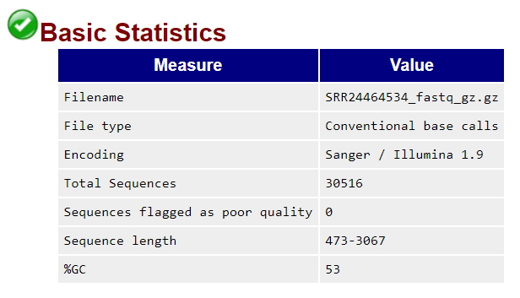

**Summary-** This section gives some simple composition statistics for the input dataset, including filename, filetype (base calls or colorspace), encoding (which FastQ format), total number of sequences, sequence length and %GC.

1. Per Base sequence quality: (insert image with summary)-

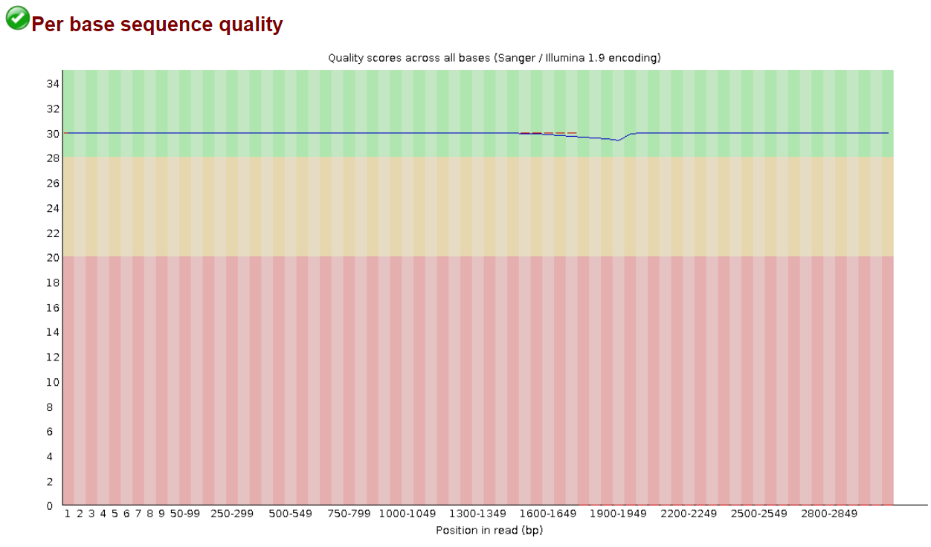

**Summary-**This plot shows the range of quality values over all bases at each position.

1. Per sequence quality score: (insert image with summary)-

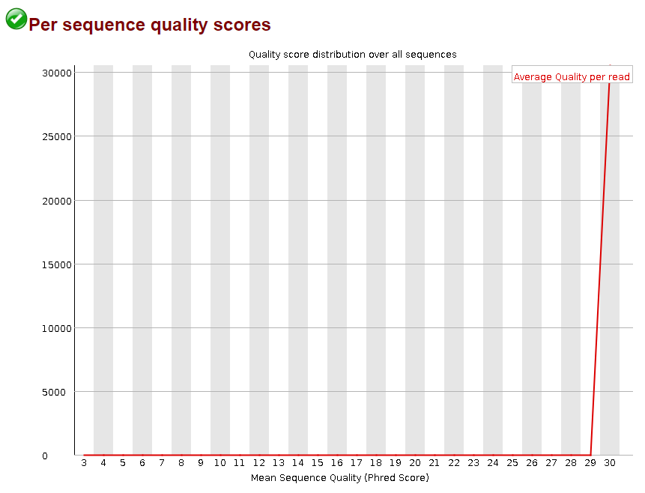

**Summary-** This plot allows you to see if there is a subset of your sequences which has universally low scores. These should represent only a small number of the total sequences.

**GitHub (DAY 7)**

Please paste your GitHub account link - github.com/PradeepNRam

**Molecular Docking (DAY 8 and 9)**

Protein Name: 2AZ5 (Crystal Structure of TNF-alpha with a small molecule inhibitor)

Protein ID –

* PDB ID: 2AZ5
* MMDB ID: 36124
* PubMed: 16284179

|  |  |  |  |
| --- | --- | --- | --- |
| Ligand Name | Ligand ID | Energy value | Dock Image - 2D |
| Caffeine | PubChem-CID-2519 | -5.6(kcal/mol) |  |
| Curcumin | PubChem-CID-969516 | -7.1(kcal/mol) |  |
| Temozolomide | PubChem-CID-5394 | -6.4(kcal/mol) |  |
| Imatinib | PubChem-CID-5291 | -10.6(kcal/mol) |  |
| Eugenol | PubChem-CID-3314 | -5.9(kcal/mol) |  |
| Lapachol | PubChem-CID-3884 | -7.2(kcal/mol) |  |
| Cianidanol | PubChem-CID-9064 | -7.6(kcal/mol) |  |
| Serpentine | PubChem-CID-73391 | -9.5(kcal/mol) |  |
| Benzidine | PubChem-CID-7111 | -6.9(kcal/mol) |  |
| Bisphenol A | PubChem-CID-6623 | -7.2(kcal/mol) |  |

**Cancer therapy (DAY 10)**

|  |  |  |  |
| --- | --- | --- | --- |
| **Cancer type** | **Hallmarks** | **Drug** | **Mechanism of drug** |
| **Hodgkin’s Lymphoma** | **PATHOLOGICAL**   * Presence of Reed-Sternberg tumor cells   **CLINICAL**   * Painless supra-diaphragmatic lymphadenopathy * Profound weight loss * Night sweats | Cyclophosphamide | **ALKYLATING AGENT**   * Damages DNA by binding to it and forming cross-linkages * The phosphor amide metabolite forms cross-linkages in between adjacent DNA strands at the guanine N-7 position |
| **Superficial spreading melanoma** | **MICROSCOPIC**   * Extracellular vesicles * Epigenetic modifications (loss of 5- hydroxymethylcytosine)   **CLINICAL**   * Mole that changes in size, shape/colour • Moles with an irregular border * Itching, bleeding/irritation of skin | Dacarbazine | **ALKYLATING AGENT**   * Cell cycle non-specific * Alkyl group attaches to N7 of guanine, causing the formation of DNA cross-links * Results in DNA fragmentation and thus cell death |
| **HER2- Positive Breast Cancer** | **MICROSCOPIC**   * Large pleomorphic tumour cells * Lymphoplasmacytic infiltrate   **CLINICAL**   * Puckering of skin * Inverted nipple * Swollen lymph nodes * Redness in and around breast area | Trastuzumab | **MONOCLONAL ANTIBODY** **(recombinant humanized Mab**)   * Binds to an extracellular domain of the HER2 receptor and inhibits HER2 homodimerization * Promotes degradation of HER2 by promoting the activity of Ubiquitin Ligase c-Cbl |
| **Acute lymphoblastic leukaemia (ALL)** | **MICROSCOPIC**   * Presence of blast cells   **CLINICAL**   * Swollen lymph nodes * Fatigue * Fever * Shortness of breath * Bleeding gums * Night sweats | CAR T-Cells | **IMMUNOMODULATION**   * Cytotoxic death of tumor cells by the recognition of neoantigens (by CAR T-cells) * Extensive stimulated cell proliferation |
| **Non-small cell lung cancer** | **MICROSCOPIC**   * Large round cancerous cells   **CLINICAL**   * Chronic cough with blood * Fatigue * Pneumonia * Weight loos | Nivolumab | **CHECKPOINT INHIBITOR**   * Prevents immunosuppression by targeting the anti-PD1 receptor |